A

Project Report on

**Mrs Culture**

Submitted in partial fulfilment of completion of the course

Advanced Diploma in IT, Networking and Cloud

Submitted by:

**Padam Singh**

**Sahil Mandewar**

**Manjeet Jangra**

**Parveen Kumar**

Under the Guidance of:

**(Edunet Mentor) Miss Mala Mishra**

|  |  |  |
| --- | --- | --- |
| IBM-Logo - Chicago Innovation | DGT introduces high end diploma courses - digitalLEARNING Magazine | Edunet Foundation-Delhi- CSR Organization profile |

Year 2023

# Abstract

**Mrs Culture** - A Journey Through Indian Culture and Travel

In today's fast-paced world, the desire to explore and connect with diverse cultures has grown significantly. "**Mrs Culture**" is a web-based platform developed using HTML, CSS, JavaScript, Bootstrap, jQuery, Laravel framework, and MySQL database to provide an immersive and user-friendly experience for travellers seeking to explore the rich tapestry of Indian culture and simplify their travel planning process.

This project aims to bridge the gap between wanderlust and convenience by offering a comprehensive repository of information on Indian culture and travel destinations, all accessible with a single click. The website boasts a sleek and intuitive user interface designed to cater to both novice and seasoned travellers.

Key Features:

1. **Culture** **Exploration**: Dive deep into the vibrant tapestry of Indian culture. Discover the diverse traditions, languages, art forms, and cuisines that make India a cultural treasure trove.

2. **Travel** **Destinations**: Explore a vast catalogue of Indian travel destinations, each accompanied by detailed information, including historical significance, local attractions, and practical travel tips.

3. **Travel** **Planning** **Tools**: Plan your trip seamlessly with interactive tools for itinerary creation, cost estimation, and accommodation booking. Personalize your journey to suit your preferences.

4. **User**-**generated** **Content**: Engage with a community of fellow travellers by sharing your own experiences, photos, and reviews. Connect with like-minded individuals and gain valuable insights.

5. **Multi**-**lingual** **Support**: **Mrs Culture** accommodates travellers from around the world with multi-lingual support, ensuring accessibility for a global audience.

6. **Responsive** **Design**: The website is optimized for various devices, making it easy to access information and plan your journey from desktops, tablets, or smartphones.

7. **Real**-**time** **Updates**: Stay informed about travel advisories, weather conditions, and local events with real-time updates, ensuring a safe and enjoyable trip.

8. **Secure** **Booking**: Securely book accommodations, transportation, and tour packages through trusted partners, ensuring a worry-free travel experience.

The integration of modern web technologies and a user-centric approach empowers travellers with the tools they need to explore India's rich cultural heritage. **Mrs Culture** aspires to be the go-to platform for anyone seeking an unforgettable journey through India, fostering cultural appreciation and facilitating hassle-free travel planning. Travelers are invited to embark on an enchanting voyage through the heart of India with **Mrs Culture** as their trusted companion.

# Acknowledgement

We would like to express our sincere gratitude to several individuals and the IBM organization for supporting us throughout our diploma study. First, we wish to express our sincere gratitude to our Edunet mentor, **Miss Mala Mishra**, for her enthusiasm, patience, insightful comments, helpful information, practical advice and unceasing ideas that have helped us tremendously at all times in our study and writing of this project report.

We also wish to express our sincere thanks to our TO-Coordinator, **Mrs Trupti Pawar** for her immense knowledge, profound experience and professional expertise in Industry has enabled us to complete this project successfully while making sure that it matched the industry standards.

I also own to my fellow friends & family who have been constant source of help to solve the problems and also helped me during the project development phase.

In addition, we are deeply indebted to the Ministry of Skill Development & Entrepreneurship and IBM for granting us the diploma course. Their technical and financial support has enabled us to complete our diploma course studies successfully.

Padam Singh

# Team Composition and Workload Division

1. Padam Singh – UI (front-end), Design Patten, Page Layout, Database (backend) & Documentation.
2. Sahil Mandewar – UI (front-end), Database (backend), Presentation & Documentation.
3. Manjeet Jangra – UI (front-end) & Design Patten.
4. Parveen Kumar– UI (front-end) & Design Patten.

|  |  |  |
| --- | --- | --- |
| Sr No | Table of Contents | Pages |
|  | Introduction to Problem | 6 |
|  | Literature Review | 7 |
|  | Proposed Solution | 8 |
|  | Requirements  4.1 Technology Stack  4.2 Hardware  4.3 Software | 9-10 |
|  | User Requirements | 11 |
|  | Design Documentation | 12 |
|  | Implementation Details | 13 |
|  | Testing | 14 |
|  | Future Scope | 15 |
|  | Conclusion | 16 |
|  | Appendix A Project Code | 17-38 |
|  | Appendix B Screenshot of Project | 39-43 |
|  | Appendix C abbreviation | 44 |
|  | References | 45 |

1. **Introduction to Problem**

Cultural travel in India presents a series of significant challenges. The process of booking flights, accommodations, and cultural experiences is often needlessly time-consuming, causing frustration for travellers. Moreover, the absence of personalized recommendations means that travellers frequently miss out on tailored cultural experiences that could enrich their journeys.

Further complicating the issue is the limited engagement with local communities and the restricted access to accurate cultural information. This not only hampers travellers’ abilities to connect with local customs but also inhibits their understanding of the cultural significance of various destinations and landmarks. These obstacles underscore the urgent need for a comprehensive and improved approach to cultural travel in India

1. **Literature Review**

Cultural Tourism as a Business Model in India” by Raja Sarkar explores how cultural tourism can be a business model and analyses the challenges. It showcases that the tourist all over the world still continue to view India as a cultural tourism hub and hence India has a great potential to be a source of tourism growth. (Sarkar, Citation2018)

“Success of Digitalization in Tourism Industry in India” by (Shigaonker, Citation2018) explores the concept of digitalization in travel & tourism, and how mobile, online travel portal and social media are creating an impact and further discusses the challenges faced by them.

Rathi in his work on tourism in 2018 (Rathi, Citation2018) titled “Digital Transformation of Travel & Tourism in India” explores how technology is a driving factor for the travel industry. He goes on to discuss how Artificial Intelligence (AI), Big Data, mobile applications, social media and Virtual Augmented Reality have become a normal accepted term in this sector and how the customers are benefited by it.

Improving heritage management in India, a working group under the chairmanship of CEO, NITI Aayog has been created by the Prime Minister’s Office (Niti Aayog, Citation2019) is a comprehensive summary of work done, planned to protect and preserve natural heritage of India, and develop possibilities of enhancing tourism and sustainable

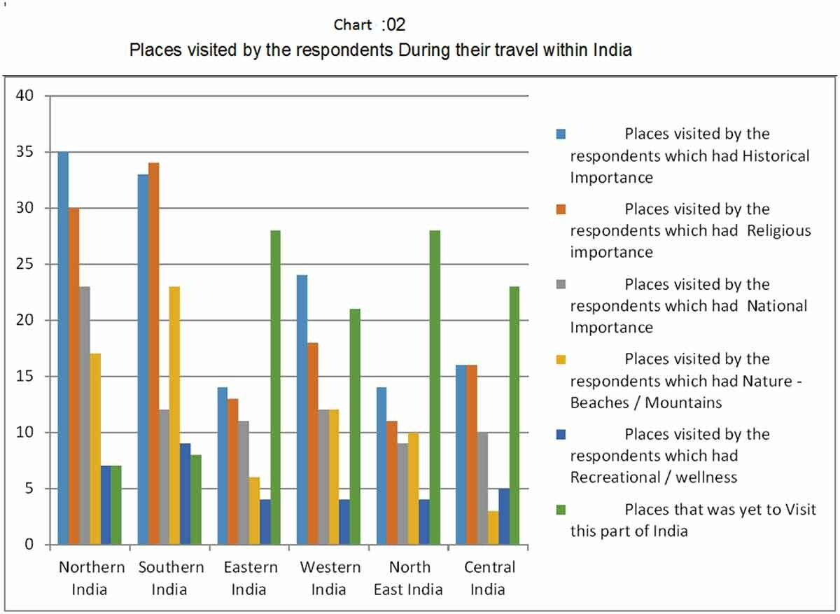

References

https://www.google.com/url?sa=i&url=https%3A%2F%2Fwww.tandfonline.com%2Fdoi%2Fpdf%2F10.1080%2F23311886.2021.1903149&psig=AOvVaw1bb9tQq7myjadBpzqJdmio&ust=1694503713593000&source=images&cd=vfe&opi=89978449&ved=0CBAQjRxqFwoTCLC8k7KEooEDFQAAAAAdAAAAABAE

1. **Proposed Solution**

Travelling through the enchanting landscape of Indian culture should be an effortless and enriching journey. Our proposed solution is poised to revolutionize cultural travel in India, addressing the challenges identified, and making it a more accessible and personalized experience.

**Streamlined Booking Process** - We recognize the hassle of time-consuming booking processes. Our platform introduces a simplified, one-stop booking system for flights, accommodations, and activities. This streamlined approach reduces the hassle, allowing you to make travel plans efficiently and effortlessly.

**Diverse Cultural Information**- A complete Indian cultural journey demands deep insights. Our platform offers an extensive cultural information hub, uncovering historical significance, local traditions, and hidden gems at every destination. Immerse yourself in the rich tapestry of India's diverse landscapes.

**Personalized Recommendations**- Recognizing the uniqueness of every traveller, our platform utilizes AI to provide personalized recommendations aligned with your interests. Whether you're a history enthusiast, a food lover, or an adventurer, your itinerary will be tailored to your preferences.

**Promoting Sustainable Travel** - We are committed to responsible tourism. Our platform collaborates with local businesses, artisans, and cultural experts, ensuring your travels leave a positive impact. Experience authentic cultural encounters while supporting local livelihoods.

In conclusion, our proposed solution is not just a travel platform; it's an entryway to a holistic cultural adventure in India. By simplifying bookings, offering diverse cultural insights, personalizing recommendations, and advocating sustainable travel, we aim to redefine your exploration of India's rich heritage. Prepare for a journey that transcends the ordinary, where culture, history, and adventure await at your fingertips.

1. **Requirements**
   1. **Technology Stack Full stack development**

Full stack development refers to the development of both front end (client side) and back end (server side) portions of web application. We have used

(HTML-CSS-JavaScript/Bootstrap at the front-end) & (Laravel Framework) as the database.

* 1. **Hardware**

• Desktop/Laptop

• Minimum 8GB RAM

• Processor 64-bit

• Solid State Drive 250GB

• Internet Connection

* 1. **Software**

**Front End**

**HTML:**

Hyper Text Markup Language (HTML) is a markup language for creating a webpage. Webpages are usually viewed in a web browser. They can include writing, links, pictures, and even sound and video. HTML is used to mark and describe each of these kinds of content so the web browser can display them correctly.

**CSS:**

CSS is the language for describing the presentation of Web pages, including colours, layout, and fonts. It allows one to adapt the presentation to different types of devices, such as large screens, small screens, or printers. CSS is independent of HTML and can be used with any XML-based markup language.

**JavaScript:** JavaScript is a lightweight, interpreted programming language. It is designed for creating network-centric applications. It is complimentary to and integrated with Java. JavaScript is very easy to implement because it is integrated with HTML. It is open and cross-platform. It is the most popular programming language in the world and that makes it a programmer’s great choice. Once you learnt JavaScript, it helps you developing great front-end as well as back-end software’s using different JavaScript based frameworks like jQuery, Node.JS etc.

**Back End**

**Laravel:** Laravel is an open-source PHP framework, which is robust and easy to understand. It follows a model-view-controller design pattern. Laravel reuses the existing components of different frameworks which helps in creating a web application. The web application thus designed is more structured and pragmatic.

**PHP:** PHP is one of the most widely used server-side scripting language for web development. Popular websites like Facebook, Yahoo, Wikipedia etc., and our very own Study tonight, are developed using PHP. PHP is so popular because it's very simple to learn code and deploy on server, hence it has been the first choice for beginners since decades. In this tutorial series we will be covering all the important concepts of PHP language from basics to advance and will also share some readyto-use, useful code snippets for beginners to kick start their web development project.

1. **User Requirements**

• Electronic Device: Mobile, Laptop, Desktop or Tablet

• Email Account

• Access to Internet

**6. Design Documentation**

**6.1 Data Flow Diagram**

**Diagram 1**

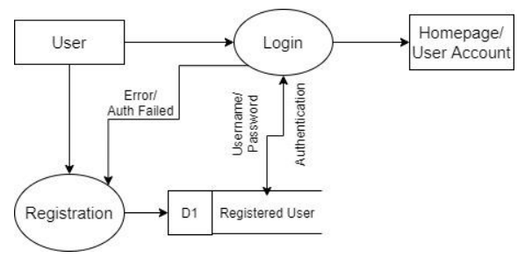

**6.2 ER Diagram Mrs Culture**

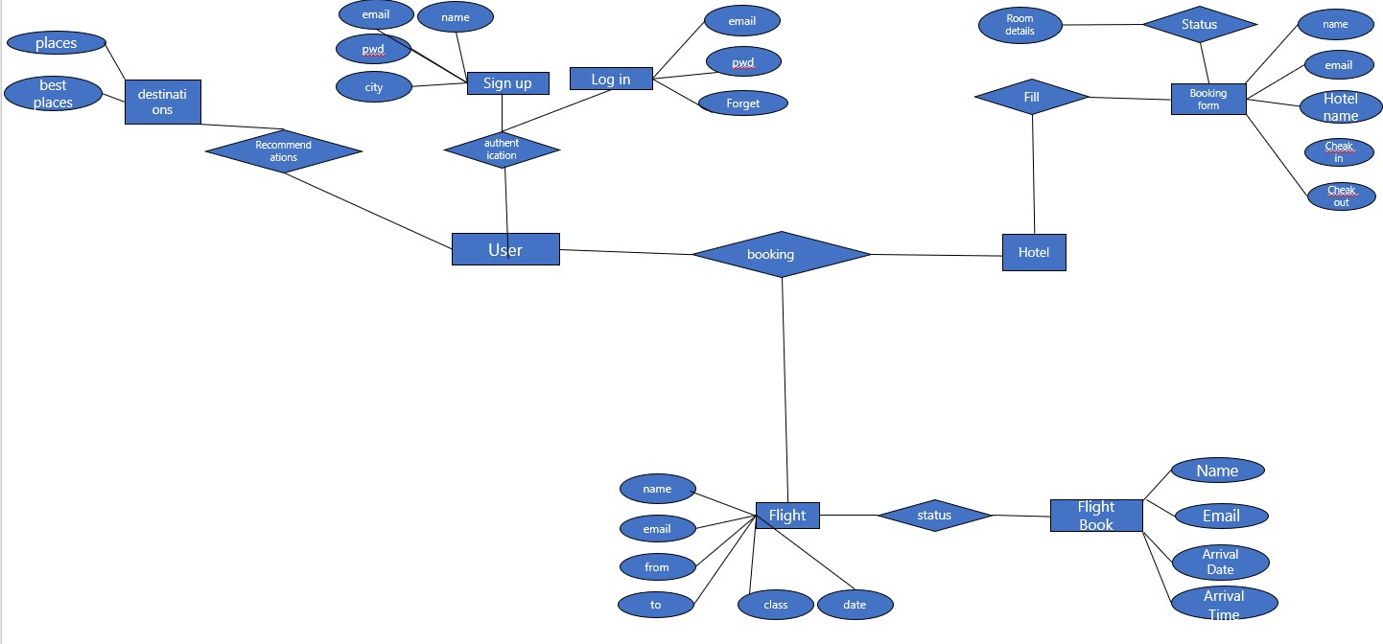

1. **Implementation Details**

**7.1 Login Page** In this module, you can login into the account registered on the website using your email id and password.

**7.2 Registration Page** In this module, you can create a user account if you haven’t already. It will include details about you like; name, mobile number, email, address and password. And then submit it, it will be saved in the database and your account is created, now you can login using your email and password anytime you want.

**7.3 Home Page** In this module, we have provided details about the website and also the necessary links. It provides a direct link to the Booking, Destinations, Contact us Forms. It provides details on how you should hotel and flight with us if you are user.

**7.4 Destination Page** Explore the vibrant tapestry of India's cultural gems. Dive into comprehensive information about each destination, uncovering its historical significance, local traditions, and must-visit spots.

**7.5 Booking Page** Implement advanced search filters, including options for destination, dates, budget, and cultural preferences, enabling travellers to refine their choices.

**7.6 Booking Check Page** Is your last stop before embarking on your cultural adventure. Confirm your bookings, review all the details, and get ready for your journey with confidence. Ensure that everything is in order before you set off on your enriching experience.

**7.7 Photo Gallery** Is where you'll feast your eyes on the visual splendour of India's culture. Explore breathtaking images of cultural landmarks, local festivals, and vibrant communities. Get a glimpse of the beauty and diversity that awaits you on your journey.

**7.8 Service Page** Is your gateway to understanding what "Mrs. Culture - A Journey Through Indian Culture and Travel" offers. Here, you'll discover our range of services, from personalized cultural itineraries to community engagement experiences. Learn how we make cultural travel in India accessible and enriching.

**7.9 Contact Page** In this module, you have to fill out a form to contact the us, and submit your name and reason for contacting us, whether it is a inquiry purpose or a complaint or request or a suggestion.

**7.10 About Page** This module contains the details about this website and project, the details about the us and our team together.

1. **Testing**

Web application refers to all applications that are accessed through a browser. This section outlines some of the testing methodologies you can use to test your web applications.

**▪ Usability testing**

Usability Testing also known as User Experience (UX) Testing, is a testing method for measuring how easy and user-friendly a software application is. A small set of target end-users, use software application to expose usability defects. Usability testing mainly focuses on user's ease of using application, flexibility of application to handle controls and the ability of application to meet its objectives.

**▪ User acceptance testing**

The objective of user acceptance testing is to make sure your application meets the expectations of the user. It ensures that the application is fit enough to be deployed and used effectively.

**• Unit Testing**

Unit testing is a software testing method by which individual units of source code—sets of one or more computer program modules together with associated control data, usage procedures, and operating procedures—are tested to determine whether they are fit for use.

**9. Future Scope**

It sounds like you're interested in developing a project called "**Mrs Culture**" that focuses on cruises, blogs, and travel packages. Combining these elements can create a unique and engaging travel experience for your audience. Here are some ideas and considerations for the future scope of your project:

Cruise Packages and Destinations: Research popular cruise destinations and create curated cruise packages that cater to different interests, budgets, and durations. Consider both ocean and river cruises. Highlight unique cultural experiences that travelers can have at each destination.

Blog Content: Create a blog section on your website to share travel stories, tips, and insights. Feature guest bloggers or travel enthusiasts who can provide diverse perspectives. Write about cultural experiences, food, traditions, and local attractions at various destinations.

Travel Packages: Design all-inclusive travel packages that combine cruises with land-based cultural experiences. These packages can be customizable to suit different preferences. Ensure that they offer value and convenience to travelers.

**10. Conclusion**

Our through "**Mrs Culture** - A Journey Through Indian Culture and Travel" has been a remarkable exploration of the complexities and wonders of cultural travel in India. The project was born from a vision to make cultural exploration in India more accessible, personalized, and sustainable, addressing the challenges travellers often face.

Our proposed solution, "Cultural Connect India," has reshaped the way cultural travellers engage with India's rich heritage. It streamlined bookings, enriched cultural insights, and championed personalized, community-engaged, and sustainable experiences.

As we conclude, the project's future holds boundless potential. We foresee an expansion beyond India's borders, embracing global cultural exploration. Sustainability will remain central, advocating for responsible tourism and community empowerment. The integration of advanced technologies, resolution of complex cultural dilemmas, and a renewed commitment to environmental conservation promise an exciting journey ahead.

With a legacy focused on mentoring a new generation of cultural travellers, we embark on the future with gratitude to our team, supporters, and fellow travellers. "Mrs. Culture" continues to celebrate India's vibrant heritage and invites all to join in this enduring cultural odyssey.

# Appendix A

**Project Code**

**Home.blade.php**

* Resources/views
  + home.blade.php

@extends('layouts.app')

@section('content')

<!-- partial:index.partial.html -->

<div class="opposites">

<div class="opposites bl"></div>

<div class="opposites tr"></div>

<div class="opposites br"></div>

<div class="opposites tl"></div>

</div>

<!-- partial -->

<div class="website-content">

<!-- Main file code -->

<div class="container-fluid" id="main-top">

<!-- here we are insert images -->

<div class="part1 ">

<div class="banner1">

<img class="slide" src="" style="background-image: url(images/n4.jpg);">

<div class="carousel-caption d-none d-md-block">

<p class="img-text">2 days tour</p>

<h6 class="img-text-h">amazing maldines tour</h6>

</div>

</div>

<div class="banner2">

<img class="slide" src="" style="background-image: url(images/n3.jpg);">

<div class="carousel-caption d-none d-md-block">

<p class="img-text">10 days curises</p>

<h6 class="img-text-h">form delhi to goa</h6>

</div>

</div>

<div class="banner3">

<img class="slide" src="" style="background-image: url(images/n2.jpg);">

<div class="carousel-caption d-none d-md-block">

<p class="img-text">Explore our most travel agency</p>

<h6 class="img-text-h">our travel agency</h6>

</div>

</div>

<div class="banner4">

<img class="slide" src="" style="background-image: url(images/n1.jpg);">

<div class="carousel-caption d-none d-md-block">

<p class="img-text">experice the</p>

<h6 class="img-text-h">best trip ever</h6>

</div>

</div>

</div>

<!-- ========== Start Nav tag ========== -->

<!-- Nav tabs -->

<div id="nav" class="">

<ul class="nav nav-tabs flex-nowrap" id="tablist" role="tablist" style="font-weight: bold;">

<li class="nav-item ul-click" onclick="">

<a class="nav-link active mx-0.5 mt-2 ms-5 text-warning " data-bs-toggle="tab" href="flight"><span

class=""><img src="Logo/flight.png" style="width: 2rem;" alt=""></span>Flight

</a>

</li>

<li class="nav-item">

<a class="nav-link mx-0.5 mt-2 text-warning bg-none" data-bs-toggle="tab" href="hotel"><span class=""><img

src="Logo/hotel.png" style="width: 2rem;" alt=""></span>Hotel</a>

</li>

<li class="nav-item">

<a class="nav-link mx-0.5 mt-2 text-warning bg-none" data-bs-toggle="tab" href="rent"><span class=""><img

src="Logo/car.png" style="width: 2rem;" alt=""></span>Car Rent</a>

</li>

</ul>

<!-- Tab panes -->

<div class="tab-content bg-secondary ps-5 pb-5"

style="width:auto; margin-left: -5%; width: 110%; height: fit-content;">

<div id="flight" class="container tab-pane active"><br>

<form class="row">

<div class="mb-3 row">

<div class="col-md-3">

<label for="inputName" class=" col-form-label ps-1">Where:</label>

<input type="text" class="form-control border-3" name="inputName" id="inputName"

placeholder="Search Location" required="">

</div>

<div class="col-md-3">

<label for="inputName" class=" col-form-label ps-1">Check-in:</label>

<input type="date" class="form-control border-3" name="inputdate" id="inputdate" placeholder="Name"

required="">

</div>

<div class="col-md-3">

<label for="inputName" class=" col-form-label ps-1">Check-out:</label>

<input type="date" class="form-control border-3" name="inputdate" id="inputdate" placeholder="Name"

required="">

</div>

<div class="col-md-1">

<label for="inputName" class=" col-form-label ps-1">Guest:</label>

<input type="number" class="form-control border-3" name="inputName" id="inputName" placeholder="No"

required="">

</div>

<div class="col-md-2">

<!-- <label for="inputName" class=" col-form-label ps-1">ind</label> -->

<input type="submit" class="form-control my-4 px-2 btn-outline-warning rounded-pill"

value="Find Flight" placeholder="Name">

</div>

</div>

</form>

</div>

<div id="hotel" class="container tab-pane fade"><br>

<form class="row">

<div class="mb-3 row">

<div class="col-md-3">

<h3>BOOK NOW</h3>

<p>BEST PRICE ONLINE</p>

</div>

<div class="col-md-3">

<label for="inputName" class=" col-form-label ps-1">Check-in:</label>

<input type="date" class="form-control border-3" name="inputdate" id="inputdate" placeholder="Name"

required="">

</div>

<div class="col-md-3">

<label for="inputName" class=" col-form-label ps-1">Check-out:</label>

<input type="date" class="form-control border-3" name="inputdate" id="inputdate" placeholder="Name"

required="">

</div>

<div class="col-md-1">

<label for="inputName" class=" col-form-label ps-1">Guest:</label>

<input type="number" class="form-control border-3" name="inputName" id="inputName" placeholder="No."

required="">

</div>

<div class="col-md-2">

<!-- <label for="inputName" class=" col-form-label ps-1">ind</label> -->

<input type="submit" class="form-control my-4 px-2 btn-outline-warning rounded-pill"

value="Find Hotel" placeholder="Name">

</div>

</div>

</form>

</div>

<div id="rent" class="container tab-pane fade"><br>

<form class="row">

<div class="mb-3 row">

<div class="col-md-4">

<label for="inputName" class=" col-form-label ps-1">Where:</label>

<input type="text" class="form-control border-3" name="inputName" id="inputName"

placeholder="Search Location" required="">

</div>

<div class="col-md-3">

<label for="inputName" class=" col-form-label ps-1">Start Date:</label>

<input type="date" class="form-control border-3" name="inputdate" id="inputdate" placeholder="Name"

required="">

</div>

<div class="col-md-3">

<label for="inputName" class=" col-form-label ps-1">Return Date:</label>

<input type="date" class="form-control border-3" placeholder="" required="" required="">

</div>

<div class="col-md-2">

<!-- <label for="inputName" class=" col-form-label ps-1">ind</label> -->

<input type="submit" class="form-control my-4 px-2 btn-outline-warning rounded-pill" value="Find Car"

placeholder="Name">

</div>

</div>

</form>

</div>

</div>

</div>

<!-- ========== End Nav tag ========== -->

Discount section ========== -->

<!-- ========== Start Recommended Hotels ========== -->

<div class="container-fluid p-5 text-center py-5">

<div class="row">

<p style="font-size: x-large;">Recommended Hotels</p>

<p>We love to tell our successful far far away, behind the word mountains, far from the<br>countries Vokalia

and Consonantia, there live the blind texts.</p>

</div>

</div>

<div class="container-fluid row ">

<div class="card col-md-3 p-2 hotel-card card-div" style="width: 18rem;">

<img src="images/hotel10.jpg" class="card-img-top" alt="...">

<div class="card-body">

<h5 class="card-title">Hotel Vintage Manali</h5>

<p class="card-text"><p style="color: black;"><img class="star" src="Logo/star-full.png"><img class="star"

src="Logo/star-full.png"><img class="star" src="Logo/star-full.png"><img class="star"

src="Logo/star-full.png"><img class="star" src="Logo/star-half.png"><span> 435 Reviews</span></p>

3 star Hotel in Manali<br>

Balcony's rooms are good view wise one of the best.</p>

<button class="btn btn-primary" data-bs-toggle="modal" data-bs-target="#staticBackdrop">Book Now</button>

</div>

</div>

<div class="card col-md-3 p-2 hotel-card" style="width: 18rem;">

<img src="images/hotel11.jpg" class="card-img-top" alt="...">

<div class="card-body">

<h5 class="card-title">The Anantmaya Resort</h5>

<p class="card-text"><p style="color: black;"><img class="star" src="Logo/star-full.png"><img class="star"

src="Logo/star-full.png"><img class="star" src="Logo/star-full.png"><img class="star"

src="Logo/star-half.png"><span> 355 Reviews</span></p>

2 star Hotel in Pune<br>

Excellent hotel located at an excellent location</p>

<button class="btn btn-primary" data-bs-toggle="modal" data-bs-target="#staticBackdrop">Book Now</button>

</div>

</div>

<div class="card col-md-3 p-2 hotel-card" style="width: 18rem;">

<img src="images/hotel3.jpg" class="card-img-top" alt="...">

<div class="card-body">

<h5 class="card-title">Treebo Trend Hotel</h5>

<p class="card-text"><p style="color: black;"><img class="star" src="Logo/star-full.png"><img class="star"

src="Logo/star-full.png"><img class="star" src="Logo/star-full.png"><img class="star"

src="Logo/star-full.png"><span> 185 Reviews</span></p>

3 star Hotel in Banglore<br>

Is one of the best destination to stay with famil</p>

<button class="btn btn-primary" data-bs-toggle="modal" data-bs-target="#staticBackdrop">Book Now</button>

</div>

</div>

<div class="card col-md-3 p-2 hotel-card" style="width: 18rem;">

<img src="images/hotel12.jpg" class="card-img-top" alt="...">

<div class="card-body">

<h5 class="card-title">Hill County Resort</h5>

<p class="card-text"><p style="color: black;"><img class="star" src="Logo/star-full.png"><img class="star"

src="Logo/star-full.png"><img class="star" src="Logo/star-full.png"><img class="star"

src="Logo/star-full.png"><img class="star" src="Logo/star-full.png"><span> 605 Reviews</span></p>

5 star Hotel in Mumbai<br>

Sea view is a very good for peaceful location</p>

<button class="btn btn-primary" data-bs-toggle="modal" data-bs-target="#staticBackdrop">Book Now</button>

</div>

</div>

</div>

<!-- ========== End Recommended Hotels ========== -->

<!-- ========== Start Most popular Traval state in India ========== -->

<div class="container-fluid p-5 text-center py-5">

<div class="row">

<p style="font-size: x-large;">Most Popular Travel States</p>

<p>We love to tell our successful far far away, behind the word mountains, far from the<br>countries Vokalia and

Consonantia, there live the blind texts.</p>

</div>

</div>

<div class="container-fluid row flex-nowrap">

<div class="col-md-6">

<div class="col-md-12 row">

<div class="col-md-6 text-center">

<a class="div-a" href="Delhi">

<div class="col-md-3 px-2 div-state">

<div class="img-state-1 hover-image-1" style="background-image: url(images/delhi-1.webp);">

</div>

<div class="div-text">

<p style="color: black;"><img class="star" src="Logo/star-full.png"><img class="star"

src="Logo/star-full.png"><img class="star" src="Logo/star-full.png"><img class="star"

src="Logo/star-full.png"><img class="star" src="Logo/star-full.png"><span> 161550 Reviews</span>

</p>

<p class="div-a-p-1" style="color: black;">Lotus Temple</p>

</div>

</div>

</a>

</div>

<div class="col-md-6 text-center">

<a class="div-a" href="Delhi">

<div class="col-md-3 px-2 div-state">

<div class="img-state-2 hover-image-2" style="background-image: url(images/delhi-2.jpg);">

</div>

<div class="div-text">

<p style="color: black;"><img class="star" src="Logo/star-full.png"><img class="star"

src="Logo/star-full.png"><img class="star" src="Logo/star-full.png"><img class="star"

src="Logo/star-full.png"><img class="star" src="Logo/star-full.png"><span> 45645 Reviews</span>

</p>

<p class="div-a-p-1" style="color: black;">India Gate</p>

</div>

</div>

</a>

</div>

<div class="col-md-6 text-center">

<a class="div-a" href="Delhi">

<div class="col-md-3 px-2 div-state">

<div class="img-state-3 hover-image-3" style="background-image: url(images/delhi-3.jpg);">

</div>

<div class="div-text">

<p style="color: black;"><img class="star" src="Logo/star-full.png"><img class="star"

src="Logo/star-full.png"><img class="star" src="Logo/star-full.png"><img class="star"

src="Logo/star-full.png"><img class="star" src="Logo/star-full.png"><span> 86854 Reviews</span>

</p>

<p class="div-a-p-1" style="color: black;">Qutub Minar</p>

</div>

</div>

</a>

</div>

<div class="col-md-6 text-center">

<a class="div-a" href="Delhi">

<div class="col-md-3 px-2 div-state">

<div class="img-state-4 hover-image-4" style="background-image: url(images/delhi-4.jpg);">

</div>

<div class="div-text">

<p style="color: black;"><img class="star" src="Logo/star-full.png"><img class="star"

src="Logo/star-full.png"><img class="star" src="Logo/star-full.png"><img class="star"

src="Logo/star-full.png"><img class="star" src="Logo/star-full.png"><span> 65424 Reviews</span>

</p>

<p class="div-a-p-1" style="color: black;">Humayun's Tomb</p>

</div>

</div>

</a>

</div>

</div>

</div>

<!-- ========== Start Sign Up for a Newsletter ========== -->

<div class=" signup-newsletter flex-nowrap my-5" style=" background-image: url(images/news-3.jpg); background-size:cover; width:120%;">

<h1 class="h1-h4">Sign Up for a Newsletter</h1>

<h4 class="h1-h4">Sign up for our mailing list to get latest updates and offers.</h4>

<div id="news-div" class="col-md-4">

<form action="" method="get">

<input id="news-div-email" type="email" placeholder="Enter Your Email" required="">

<input id="news-div-submit" type="submit">

</form>

</div>

</div>

<!-- ========== End Sign Up for a Newsletter ========== -->

<footer>

<div id="footer" class="container-fluid " style="margin-top: -150px; padding: 100px; color: white;">

<div class="row m-5" style="padding-top: 100px;">

<div class="col-md-3">

<h6>**Mrs Culture** Agency</h6>

<p>Facilis ipsum reprehenderit nemo molestias. Aut cum mollitia reprehenderit. Eos cumque dicta adipisci architecto culpa amet.</p>

<a href="https://www.facebook.com/mrscultureoffical/"><img class="news-logo" src="Logo/facebook (1).png" alt=""></a>

<a href=""><img class="news-logo" src="Logo/twitter.png" alt=""></a>

<a href="https://www.instagram.com/mrs._culture/"><img class="news-logo" src="Logo/instagram (1).png" alt=""></a>

<a href="https://www.youtube.com/@m_rs_culture"><img class="news-logo" src="Logo/youtube (1).png" alt=""></a>

</div>

<div class="col-md-1" style="font-size: smaller;">

<h6>Book Now</h6>

<a style="text-decoration: none; color:white" href="flight"><div>Flight</div></a>

<a style="text-decoration: none; color:white" href="hotel"><div>Hotels</div></a>

<a style="text-decoration: none; color:white" href=""><div>Tour</div></a>

<a style="text-decoration: none; color:white" href=""><div>Car Rent</div></a>

<a style="text-decoration: none; color:white" href="destination"><div>Beach & Resorts</div></a>

<a style="text-decoration: none; color:white" href="cruises"><div>Cruises</div></a>

</div>

<div class="col-md-1" style="font-size: smaller;">

<h6>Top Deals</h6>

<a style="text-decoration: none; color:white" href=""><div>Edina Hotel</div></a>

<a style="text-decoration: none; color:white" href=""><div>Quality Suites</div></a>

<a style="text-decoration: none; color:white" href=""><div>The Hotel Zephyr</div></a>

<a style="text-decoration: none; color:white" href=""><div>Da Vinci Villa</div></a>

<a style="text-decoration: none; color:white" href=""><div>Hotel Epikk</div></a>

</div>

<div class="col-md-4" style="font-size: smaller;">

<h6>Blog Post</h6>

<div>The Ultimate Packing List For Female Travelers</div>

<div>How These 5 People Found The Path to Their Dream Trip</div>

<div>A Definitive Guide to the Best Dining and Drinking Venues in the City</div>

</div>

<div class="col-md-3" style="font-size: smaller;">

<h6>Contact Information</h6>

<div>Address: Mumbai</div>

<div><a href="mailto:mrsculture.offical@gmail.com" style="text-decoration: none; color: white;">mrsculture.offical@gmail.com</a></div>

<div><a href="tel:+919310521020"></a>+919310521020</div>

<div class="footer-copyright text-center " style="margin-left: -190px">@ 2023 copyright:

<a href="home">mrsculture</a>

<p style="text-align: center;">| All rights reserved I</p>

</div>

</div>

</div>

</div>

</footer>

<div class="floating-icon">

<a href="https://www.facebook.com/mrscultureoffical/"><img class="m-1" src="Logo/facebook (1).png" style="width: 20px;" alt=""

srcset="" data-bs-toggle="tooltip" data-bs-placement="right" title="FaceBook"></a>

<a href="https://www.instagram.com/mrs._culture/"><img class="m-1" src="Logo/instagram (1).png" style="width: 20px;" alt=""

srcset="" data-bs-toggle="tooltip" data-bs-placement="right" title="Instagram"></a>

<a href="https://www.youtube.com/@m_rs_culture"><img class="m-1" src="Logo/youtube (1).png" style="width: 20px;" alt=""

srcset="" data-bs-toggle="tooltip" data-bs-placement="right" title="Youtube"></a>

</div>

<div class="floating-icon-1 " >

<a href="main-top">

<div style="width: 30px; height: 30px; align-items: end; background-image: url(Logo/arrow-up.png); background-size: cover;"></div>

</a>

</div>

</div>

@endsection

**Project Code**

**login.blade.php**

* Resources/views/auth
  + login.blade.php

@extends('layouts.app')

@section('content')

<style>

body{

background-image: url(images/login-bg.jpg);

background-size: cover;

overflow-x: hidden;

}

.social-tab{

text-align: center;

border-radius: 30px;

background-color: light; width:400px; color:rgb(0, 0, 0); height:40px;

outline-color: black;

margin-bottom: 20px;

margin-top: 20px

border: black;

padding-top: 5px;

}

.social-tab a{

text-decoration: none

}

.social-main{

align-items: center;

padding: 35px;

}

#main-login:hover{

box-shadow: 0px 0px 15px rgba(0, 0, 0, 0.51);

}

</style>

<div class="container-fluid" style="color: rgb(255, 255, 255); font-size: x-large; margin-left:-90%; margin-top:70%; ">

<div style=" margin-left:50px; margin-top:20%">

<div>

<img src="Logo/Mrs web icon png.png" style="width: 60px;" alt="">

Mrs Culture

</div>

<div>

Sign in or create an account

</div>

</div>

</div>

<div style="width: 500px; margin-left: 60%; margin-top: -80%; padding:10px; background-color:white; border-radius: 10px;">

<h3> <strong>Sign in</strong> <hr style="color: rgb(255, 1, 1)"></h3>

<div class="form-body">

<form method="POST" action="{{ route('login') }}">

@csrf

<div class="form-group" style="margin-bottom: 20px;">

<label for="email" class="col-md-4 col-form-label text-md-start">Email Address</label>

<input id="email" type="email" class="form-control @error('email') is-invalid @enderror" name="email" value="{{ old('email') }}" required autocomplete="email" autofocus>

@error('email')

<span class="invalid-feedback" role="alert">

<strong>{{ $message }}</strong>

</span>

@enderror

</div>

</div>

<div class="form-group" style="margin-bottom: 20px;">

<label for="password" class="col-md-4 col-form-label text-md-start">Password</label>

<input id="password" type="password" class="form-control @error('password') is-invalid @enderror" name="password" required autocomplete="current-password">

@error('password')

<span class="invalid-feedback" role="alert">

<strong>{{ $message }}</strong>

</span>

@enderror

</div>

<div class="form-group" style="margin-bottom: 20px;">

<div class="form-check">

<input class="form-check-input" type="checkbox" name="remember" id="remember" {{ old('remember') ? 'checked' : '' }}>

<label class="form-check-label" for="remember">

Remember Me

</label>

</div>

</div>

<div class="mb-3 login-signup social-main">

<div style="margin-bottom: 15px">__________Or__________</div>

<a style="text-decoration: none;" href="https://www.facebook.com/login.php" target="_blank" rel="noopener noreferrer">

<div class="social-tab" style="border: 2px rgba(0, 0, 0, 0.500) solid;" >

<img class="ss" id="logo" src="Logo/facebook (1).png" alt="">

Connect with Facebook

</div>

</a>

<a style="text-decoration: none;" href="https://accounts.google.com/v3/signin/identifier?dsh=S1979752111%3A1687789335513299&continue=https%3A%2F%2Fads.google.com%2Fnav%2Flogin%3Fsubid%3Din-en-adon-awa-sch-c-bbb%21o3%7E13ada7984da217669613c301d2aefd26%7Ep71078840948%7E&followup=https%3A%2F%2Fads.google.com%2Fnav%2Flogin%3Fsubid%3Din-en-adon-awa-sch-c-bbb%21o3%7E13ada7984da217669613c301d2aefd26%7Ep71078840948%7E&ifkv=Af_xneHYH_D8Mr7v4l5-kJXc3MniY858IF1UmsEa-pRK1soNBV23tHGAuvBO27TBw19t7sJso4kdRQ&osid=1&passive=1209600&service=adwords&flowName=GlifWebSignIn&flowEntry=ServiceLogin" target="_blank" rel="noopener noreferrer">

<div class="social-tab" style="border: 2px rgba(0, 0, 0, 0.500)solid">

<img class="ss" id="logo" src="Logo/google.png" alt="">

Connect with Google

</div>

</a>

<a style="text-decoration: none;" href="https://twitter.com/i/flow/login" target="_blank" rel="noopener noreferrer">

<div class="social-tab" style="border: 2px rgba(0, 0, 0, 0.500)solid">

<img class="ss" id="logo" src="Logo/twitter.png" alt="">

Connect with Twitter

</div>

</a>

<div class="form-group" style="margin-bottom: 20px;">

<div class="col-md-8 offset-md-0">

<button type="submit" class="btn btn-warning">

Login

</button>

@if (Route::has('password.request'))

<a class="btn btn-link" href="{{ route('password.request') }}">

{{ __('Forgot Your Password?') }}

</a>

@endif

</div>

</div>

</form>

</div>

@endsection

**Project Code**

**register.blade.php**

* Resources/views/auth
  + register.blade.php

@extends('layouts.app')

@section('content')

<style>

body{

background-image: url(images/login3.jpg);

background-size: cover;

overflow-x: hidden;

}

label{

margin-bottom: -20px;

margin-top: -20px;

}

.social-tab{

text-align: center;

border-radius: 30px;

background-color: light; width:400px; color:rgb(0, 0, 0); height:40px;

outline-color: black;

margin-bottom: 20px;

margin-top: 20px

border: black;

padding-top: 5px;

}

.social-tab a{

text-decoration: none

}

.social-main{

align-items: center;

padding: 35px;

}

#main-login:hover{

box-shadow: 0px 0px 15px rgba(0, 0, 0, 0.51);

text-decoration: bol

}

</style>

<div class="container-fluid" style="color: rgb(255, 255, 255); font-size: x-large; margin-left:-90%; margin-top:70%; ">

<div style=" margin-left:50px; margin-top:20%">

<div>

<img src="Logo/Mrs web icon png.png" style="width: 60px;" alt="">

Mrs Culture

</div>

<div>

Sign in or create an account

</div>

</div>

</div>

<div style="width: 500px; margin-left: 60%; margin-top: -80%; padding:10px; background-color:white; border-radius: 10px;">

<h3><strong>Create an account</strong><hr style="color: rgb(255, 1, 1)"></h3>

<div class="form-body">

<form method="POST" action="{{ route('register') }}">

@csrf

<div class="form-group" style="margin-bottom: 20px;">

<label for="name" class="col-md-4 col-form-label text-md-start">{{ __('Name') }}</label>

<input id="name" type="text" class=" form-control @error('name') is-invalid @enderror" name="name" value="{{ old('name') }}" required autocomplete="name" autofocus>

@error('name')

<span class="invalid-feedback" role="alert">

<strong>{{ $message }}</strong>

</span>

@enderror

</div>

<div class="form-group" style="margin-bottom: 20px;">

<label for="gender" class="col-md-4 col-form-label text-md-start">{{ __('Gender') }}</label>

<select style="margin-bottom: 10px;" class="form-control @error('gender') is-invalid @enderror" name="gender" id="gender">

<option value="">-Select Gender-</option>

<option value="Male">Male</option>

<option value="Female">Female</option>

<option value="Other">Other</option>

</select>

</div>

<div class="form-group" style="margin-bottom: 20px;">

<label for="city" class="col-md-4 col-form-label text-md-start">{{ __('City') }}</label>

<input id="city" type="text" class=" form-control @error('city') is-invalid @enderror" name="city" value="{{ old('city') }}" required autocomplete="city" autofocus>

@error('city')

<span class="invalid-feedback" role="alert">

<strong>{{ $message }}</strong>

</span>

@enderror

</div>

<div class="form-group" style="margin-bottom: 20px;">

<label for="email" class="col-md-4 col-form-label text-md-start">Email Address</label>

<input id="email" type="email" class="form-control @error('email') is-invalid @enderror" name="email" value="{{ old('email') }}" required autocomplete="email" autofocus>

@error('email')

<span class="invalid-feedback" role="alert">

<strong>{{ $message }}</strong>

</span>

@enderror

</div>

</div>

<div class="form-group" style="margin-bottom: 20px;">

<label for="password" class="col-md-4 col-form-label text-md-start">{{ __('Password') }}</label>

<input id="password" type="password" class="form-control @error('password') is-invalid @enderror" name="password" required autocomplete="new-password">

@error('password')

<span class="invalid-feedback" role="alert">

<strong>{{ $message }}</strong>

</span>

@enderror

</div>

<div class="form-group" style="margin-bottom: 20px;">

<label for="password-confirm" class="col-md-4 col-form-label text-md-start">{{ __('Confirm Password') }}</label>

<input id="password-confirm" type="password" class="form-control" name="password_confirmation" required autocomplete="new-password">

</div>

<div class="form-group" style="margin-bottom: 20px;">

<div class="col-md-8 offset-md-0">

<button type="submit" class="btn btn-warning">

Register

</button>

</div>

</div>

</form>

</div>

@endsection

# Appendix B

**Screenshot of Project**

**Home page**

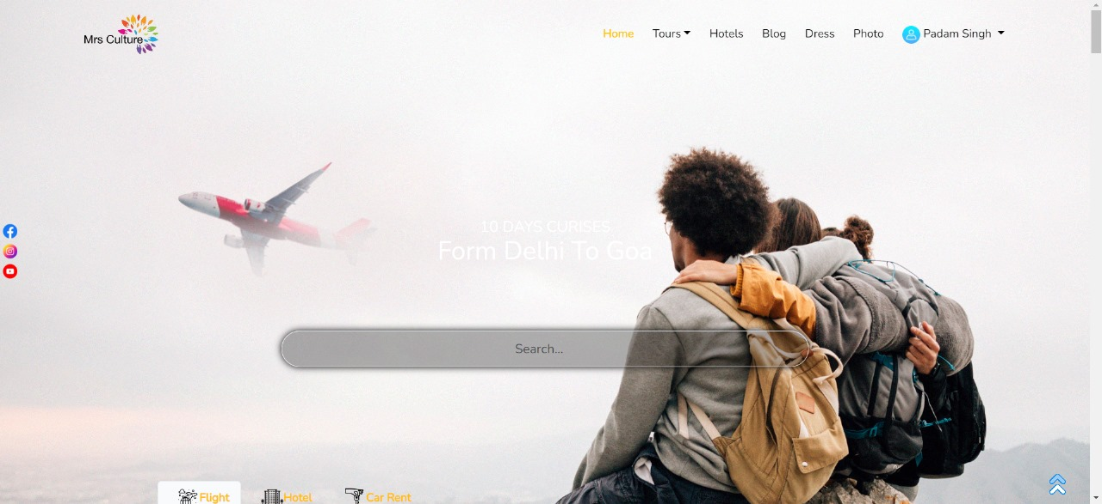

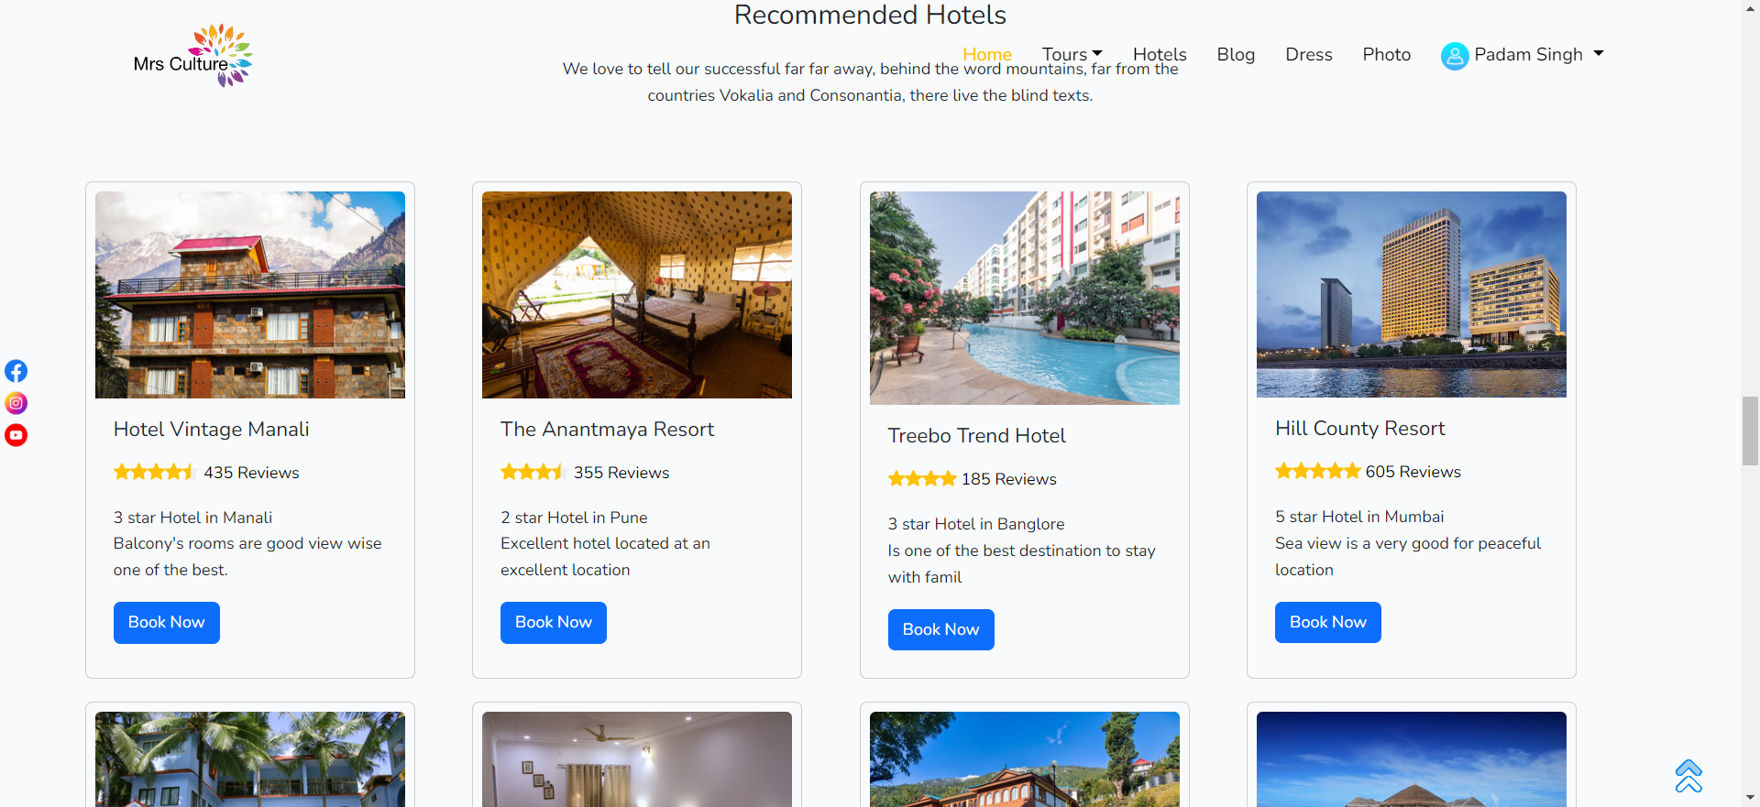

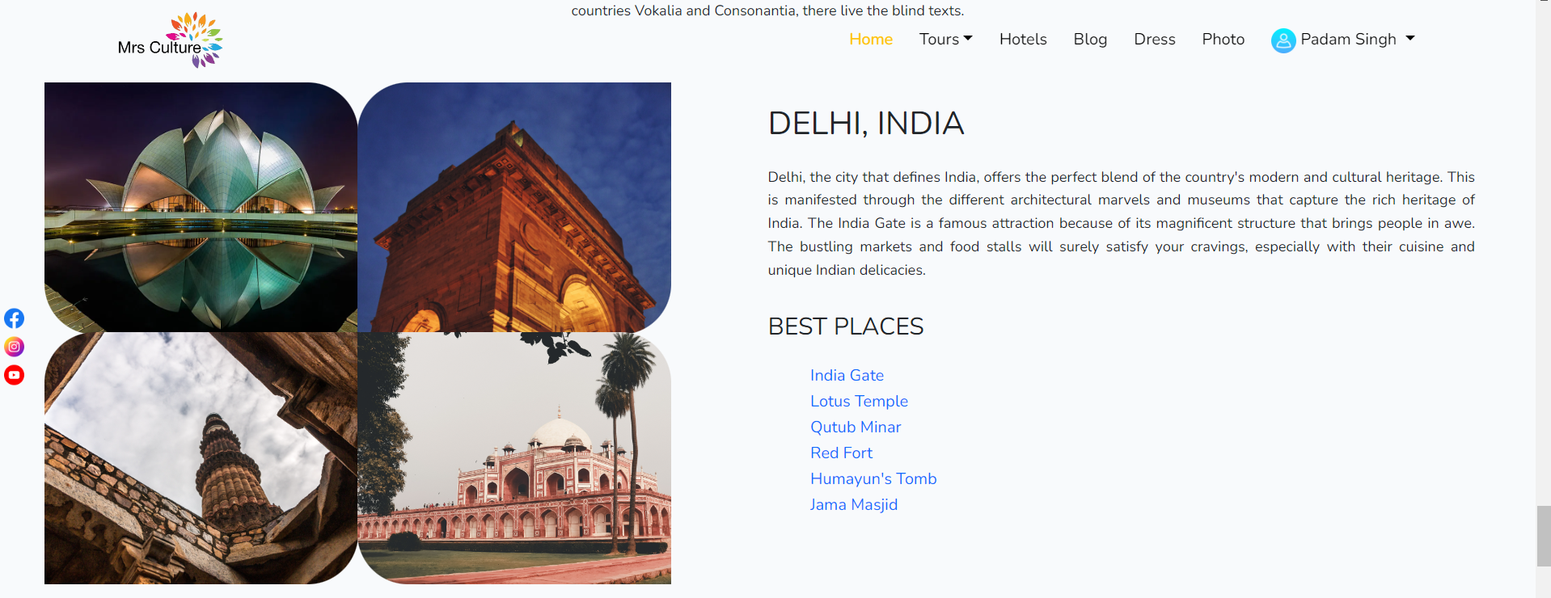

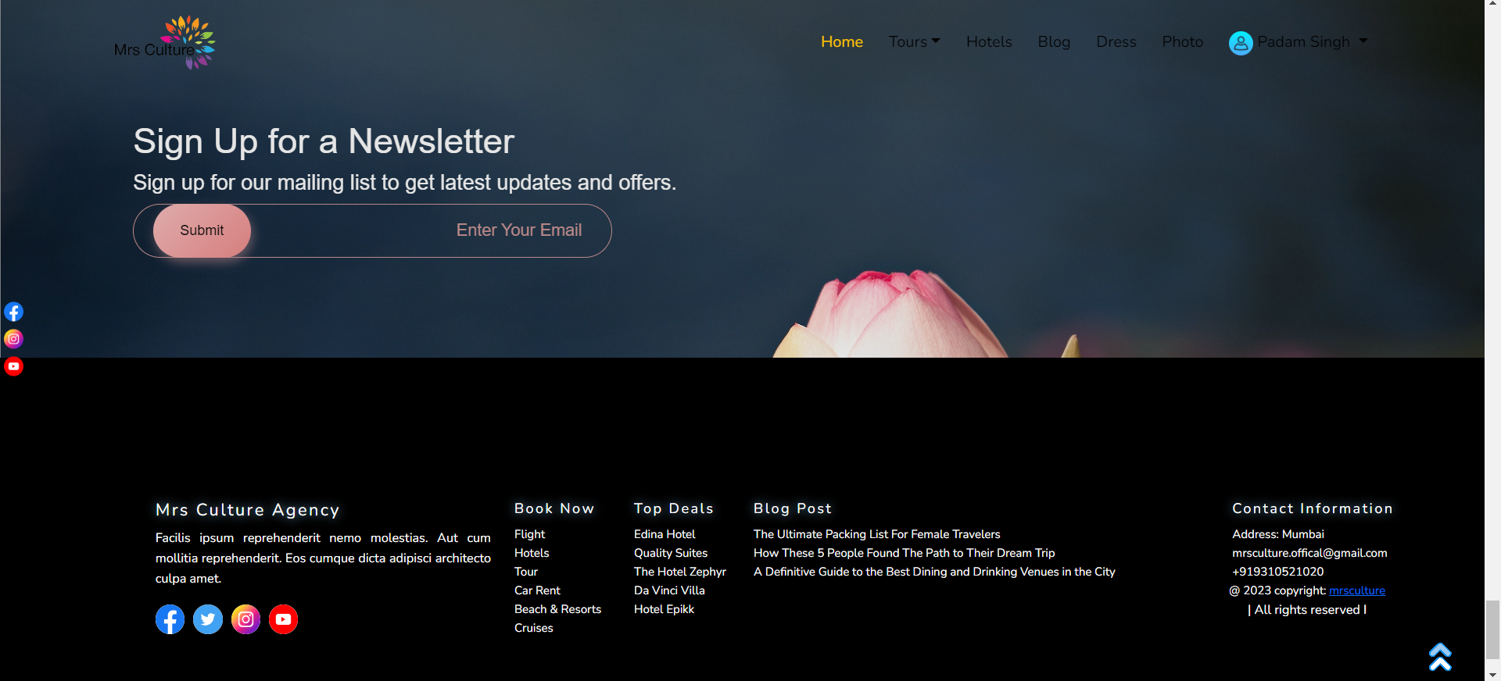

**Login page**

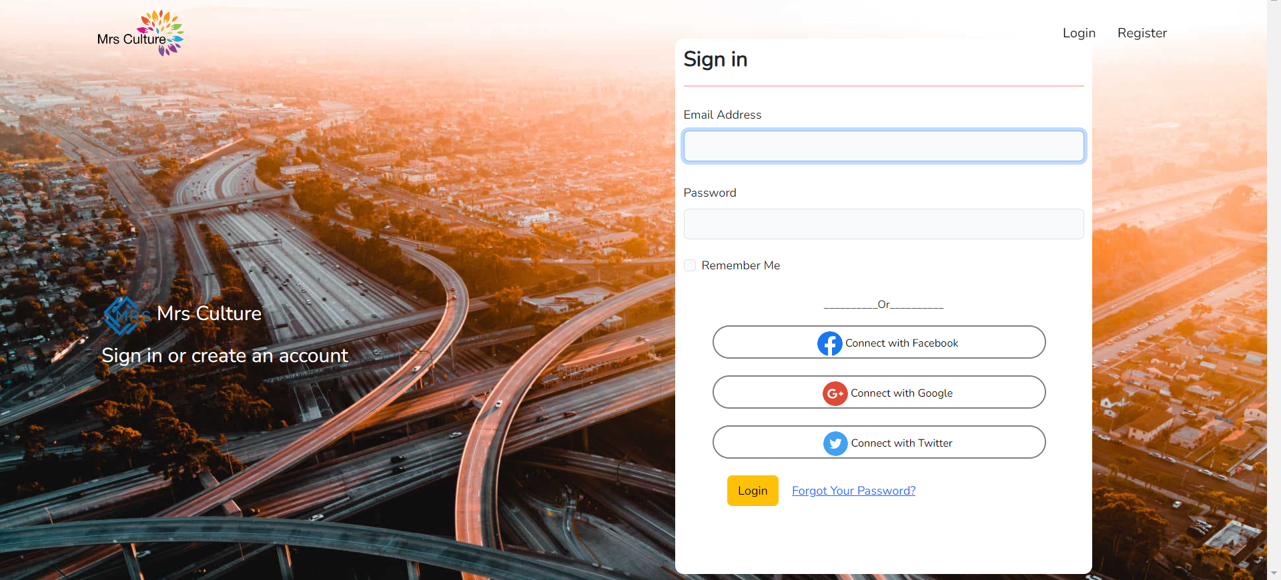

**Register page**

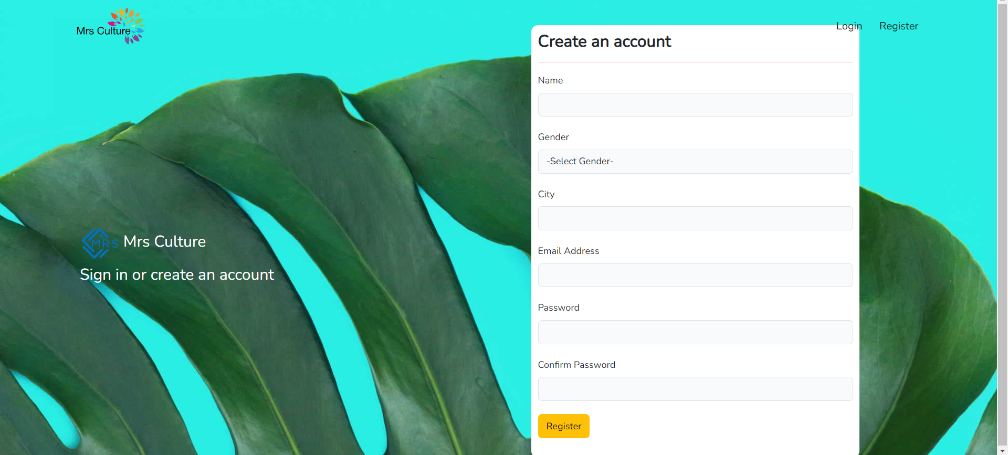

**Destination**

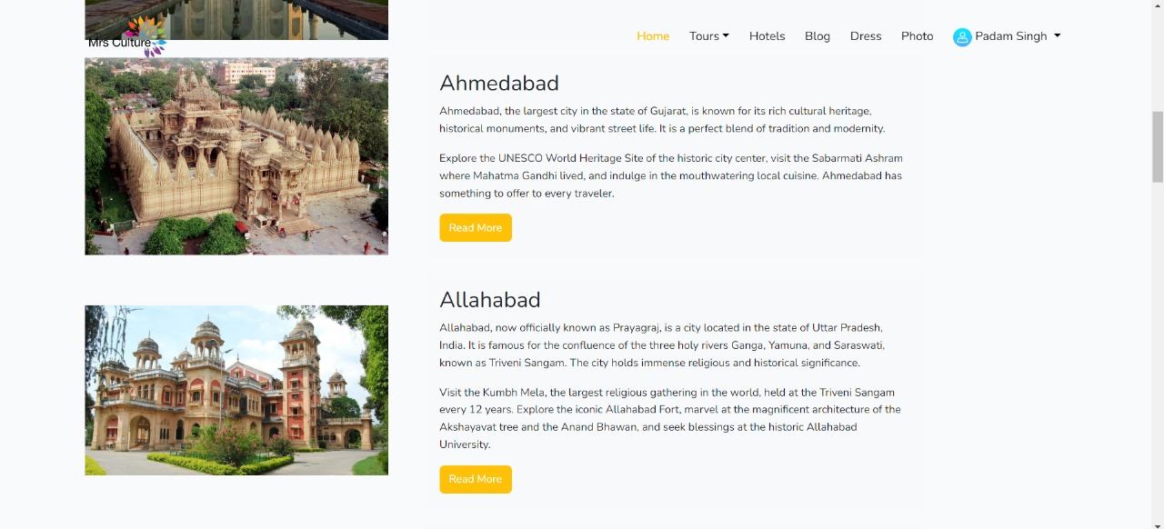

**Flight**

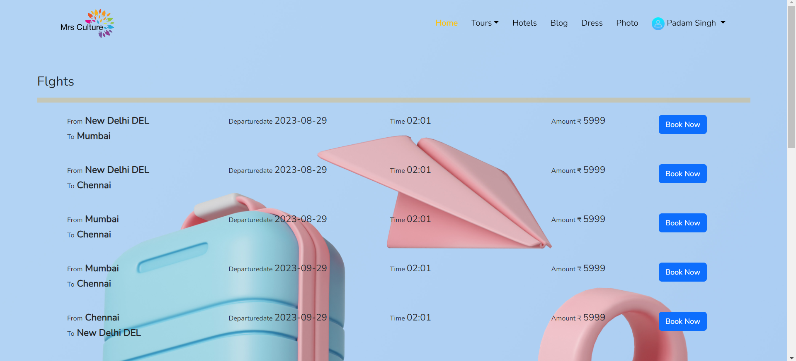

**Flight booking**

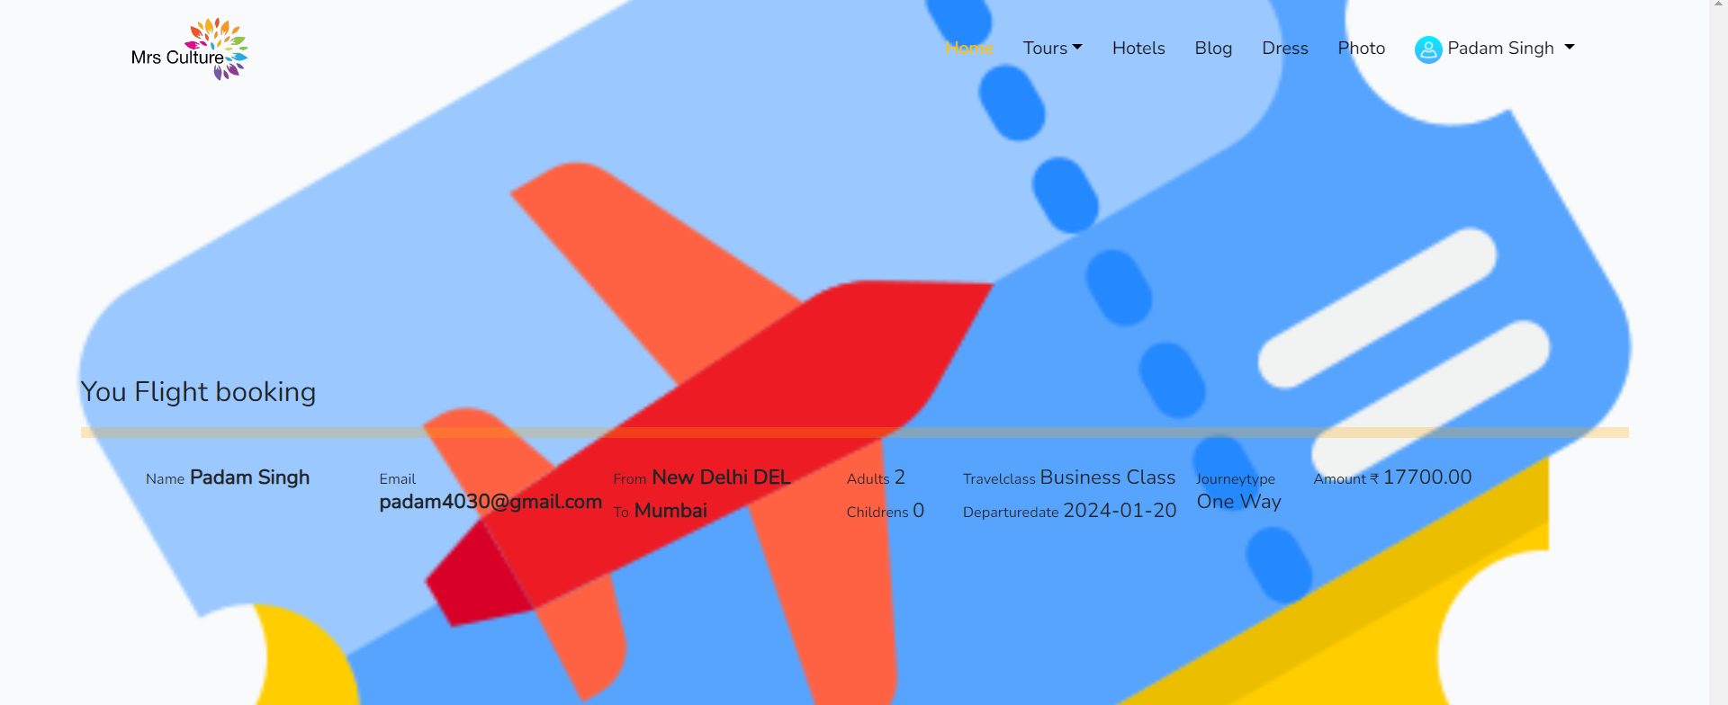

**Dress gallery**

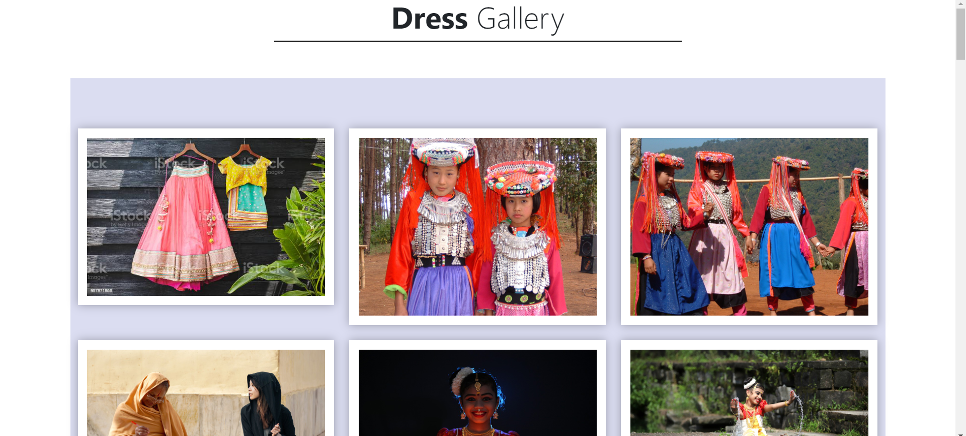

**Photo gallery**

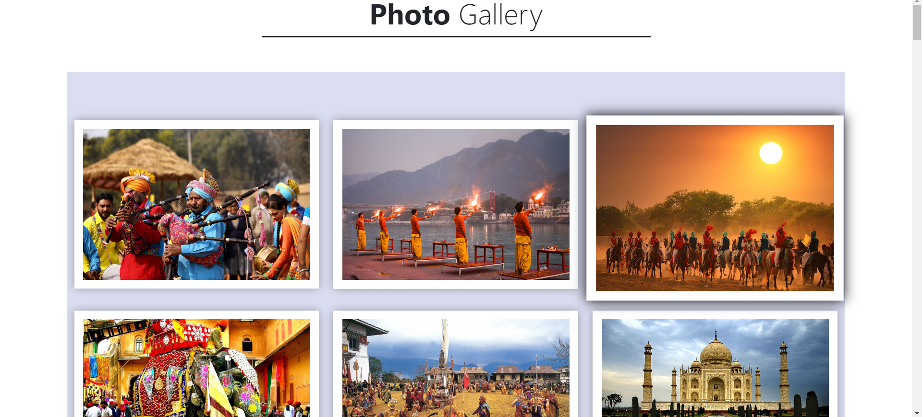

**About**

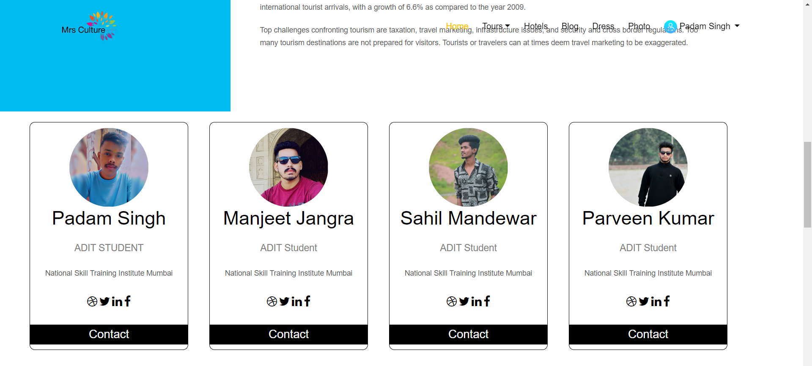

**Service**

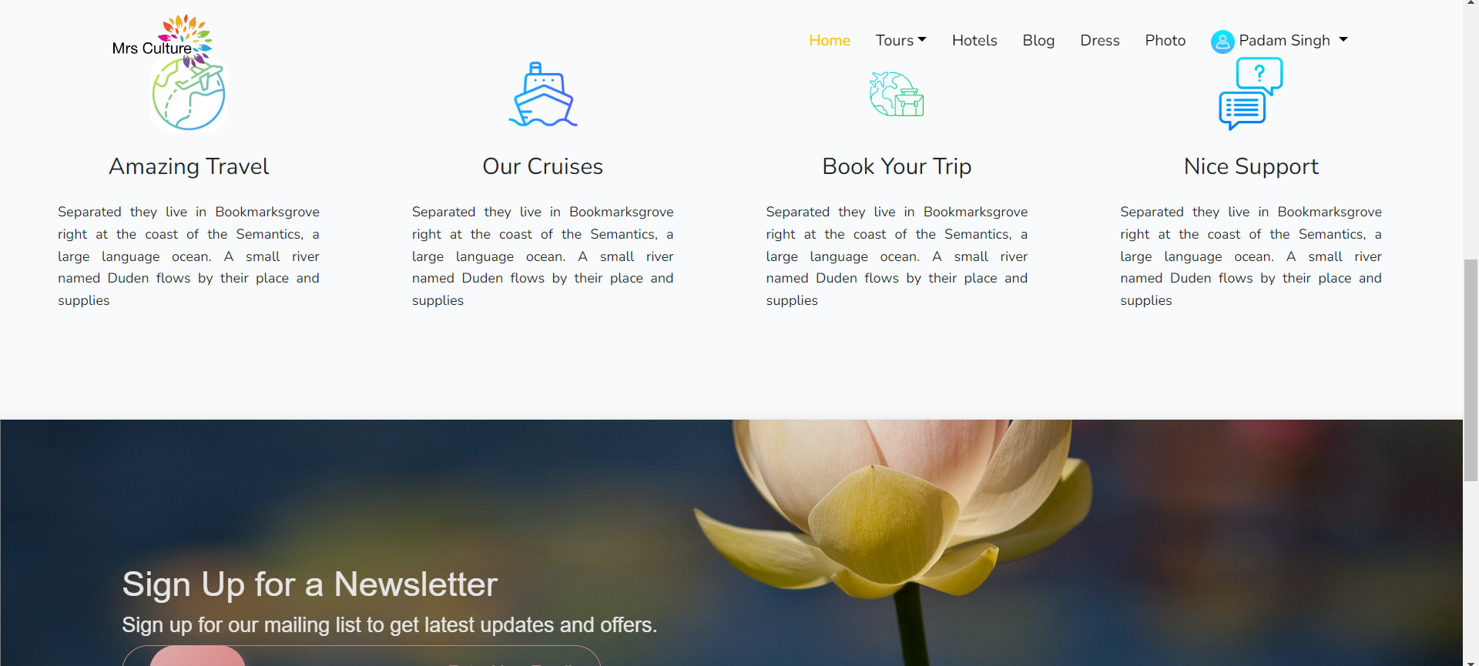

# Appendix C

## Abbreviation

HTML – Hypertext Markup Language

CSS – Cascading Style Sheet

PHP – Hypertext Preprocessor

JS – JavaScript

Pwd – Password

# References

[1] <https://laravel.com/docs/10.x>

[2] php.net/docs.php

[3] <https://www.w3schools.com/html/default.asp>

[4] <https://www.w3schools.com/css/default.asp>

[5] <https://www.w3schools.com/java/default.asp>

[6] <https://www.w3schools.com/howto/default.asp>

[7] <https://www.w3schools.com/bootstrap5/index.php>

[8] <https://www.w3schools.com/mysql/default.asp>

[9] <https://www.w3schools.com/jquery/default.asp>

[10] <https://www.pexels.com/search/indian%20culture%20images/>

[11] <https://www.flaticon.com/>